**TO DO LIST: (do not DELETE thank you ☺ )**

**9th Week - Start Requesting for your Panelist - July 28th to August 02nd**

**10th Week - 11th Week (August 4th - August 16th) - Panel Defense**

**12th Week - 13th Week (August 18th - August 30th) - Client Defense**

**13th Week as well - Proofread of Documentation**

**Sept. 03rd - Collection of Official Receipts**

**Note: Accomplish requirements in wikipage re: Panel and Proofreading**

**Sept. 03rd last day submission of Documentation plus CD at 7:30am.  No Extensions.**

**(ESTIMATION Pa lang ito ☺ okie? )**

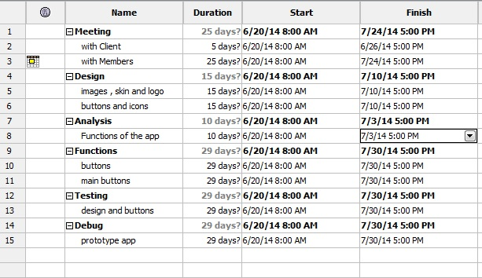

@alecza – gawa ka ng design for android ung home page , request page and news page ty :D

Eto yung CFD , DFD natin nung INTSDEV

**CFD**

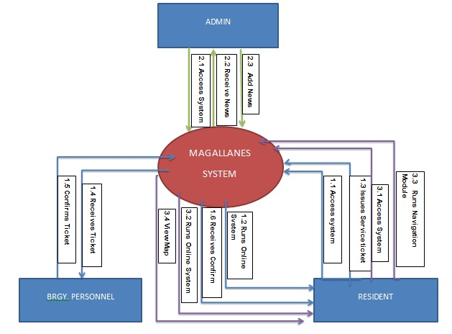

**DFD**

**Level 0**

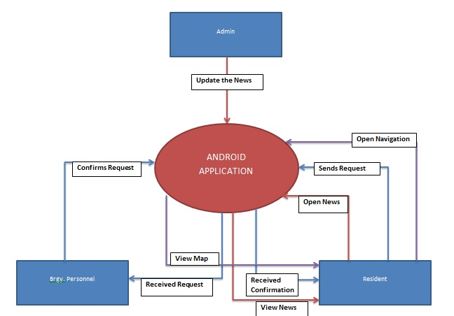

**Level 1**

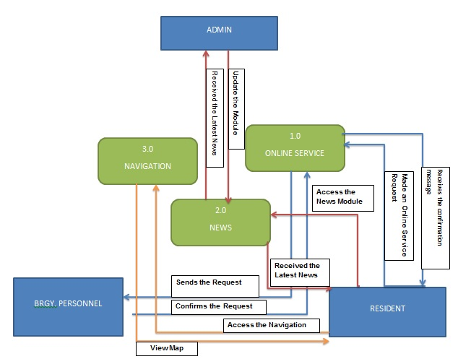

**Level 2**

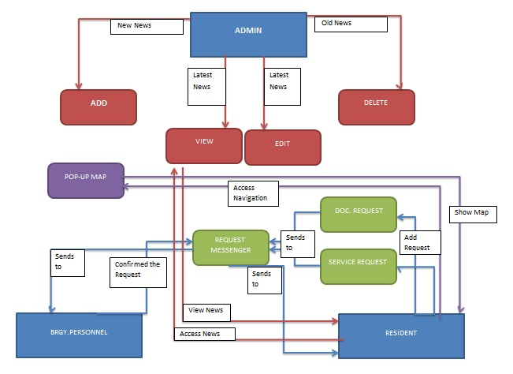

**(P.S : “di ko pa siya narerevise :D ”)**